CH2203: Synthesis and Characterization Laboratory
-------------------------------------------------------------------------
Expt.: Diels-Alder reaction of Anthracene & Maleic anhydride

Aim and Objectives: In this lab, we will learn that the 4π electrons of the diene (anthracene) will react with the 2π electrons of the dienophile (maleic anhydride) to give the polycyclic Diels-Alder product.

Apparatus Requirement:
Round Bottom (RB) flask; Reflux condenser; Celite funnel; Measuring cylinder; Filter paper

Chemicals Requirement:
- Anthracene
- Maleic Anhydride
- o-Xylene

Molecular Wt. and Physical Details of Reagents:

Molecular formula of Anthracene =C₁₄H₁₀
Molecular weight of Anthracene = 178.2340 g/mole

Molecular formula of Maleic Anhydride = C₄H₂O₃
Molecular weight of Maleic Anhydride = 98.0570 g/mole

Experimental Procedure:

- 1 g of anthracene was weighed and taken in a cleaned and dried round bottom flask.

- 0.5 g of maleic anhydride was weighed and taken in the same round bottom flask.

- 10 ml o-xylene was added to the reaction mixture and the contents of the flask was mixed thoroughly.

- Then, the RB flask was warmed with a heating-bath previously maintained at 140°C for about 25 min with constant stirring.

- After 25 min the heating bath was removed and the reaction mixture was allowed to cool to room temperature.

- After few minutes the RB was transferred to an ice-bath for further cooling and left for 10 minutes.

- After 10 minutes white precipitate was observed and which was filtered through celite funnel using vacuum.

- The precipitate was washed with ice-cold xylene, drained well to give crude Diels-Alder product.

- The weight of the crude product was taken.

- Melting point of the product was checked.

- Further characterization was done by IR spectra, 1H NMR spectra & 13C NMR spectra.

Reaction Mechanism:

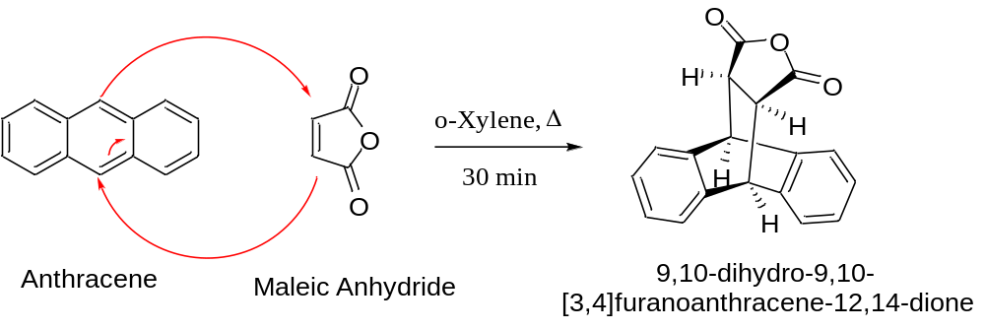

Results & Observation:

Yield: 1.43 g % of Yield: 96.95% MP: 257- 259 °C

TLC System: R_{f} = 0.44 (20% EtOAc in n-hexane)

Compound Characterization:

IR Frequencies: 1839, 1757, 1441, 1212, 1053 cm⁻¹

¹H-NMR: (400 MHz, DMSO-d6) δ 7.47 (dd, J = 5.4, 3.2 Hz, 2H), 7.36 – 7.29 (m, 2H), 7.18 (td, J = 5.9, 3.2 Hz, 4H), 4.86 (s, 2H), 3.65 (s, 2H)

¹³C-NMR: (126 MHz, DMSO-d6) δ 176.75, 146.34, 144.32, 132.29, 131.76, 130.08, 129.69, 53.14, 49.56.

Conclusion:

In summary, we have done the Diels-Alder reaction of anthracene and maleic anhydride. The chemical yield was 96.95%. Further, the compound was characterised by IR spectra, NMR spectra and melting point was also checked.

